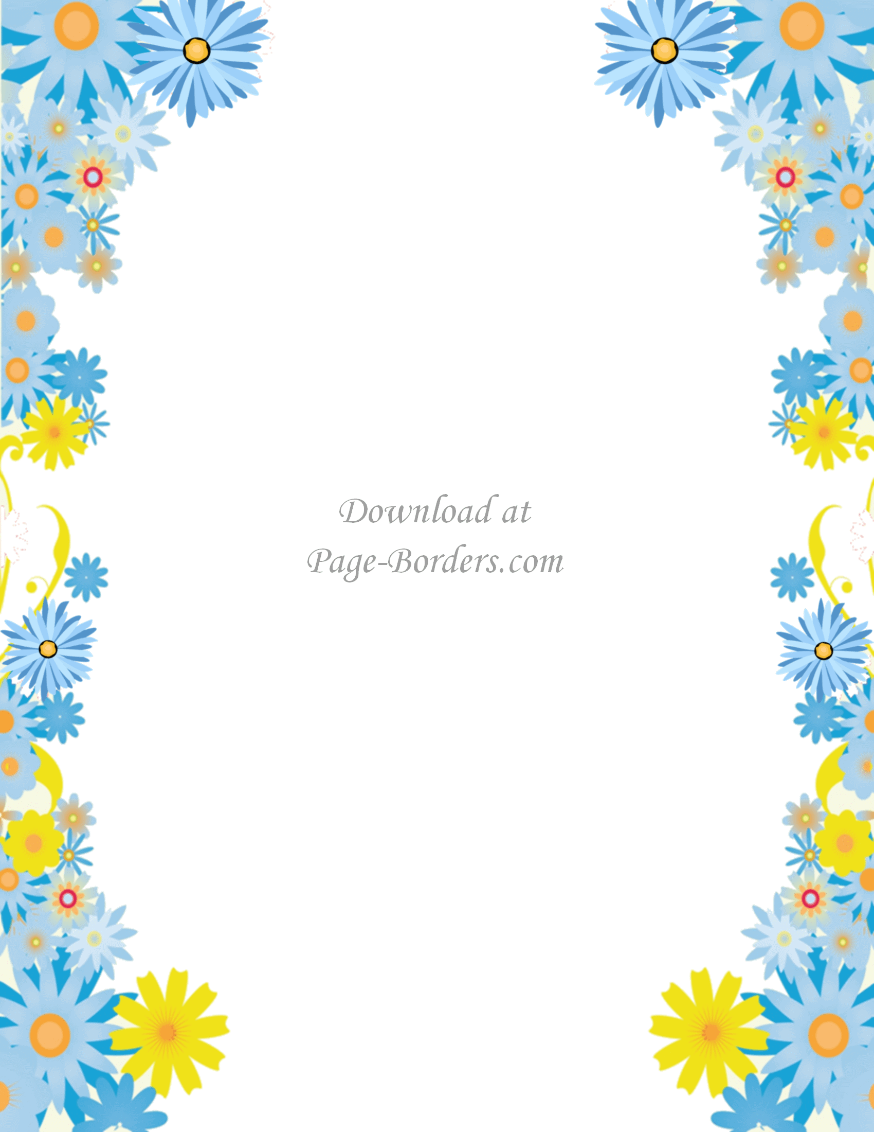**August 2022**

**Hello families!**

**Welcome to Fifth Grade at Doyle Elementary! My name is Mrs. Strohl and I am looking forward to a new year filled with wonderful learning experiences as your child’s fifth grade teacher!**

**Let me take this opportunity to tell you a little about myself.  When I first started teaching in Central Bucks School District eighteen years ago, I was lucky enough to start at Doyle Elementary. Over the years I have taught both third and sixth grades at Cold Spring Elementary, and fourth and fifth grades at Doyle Elementary.**

**This summer I have been able to share a lot of time and laughs with my family making beautiful memories along the way. My husband Andy and I enjoyed many summer adventures with our soon to be 3-year-old son, Drew. We spent a lot of time at the beach and quickly learned that Drew LOVES the ocean. Throughout the summer we enjoyed going on long walks, visiting parks, playing in the sprinkler, and swimming in our pool. I cannot wait to hear all about your summer adventures!**

**Summer would not be complete without reading lots of excellent books. Reading in the sunshine is one of my favorite summertime activities, and I am already onto my 6th book of the summer.  I hope you have been reading a lot of great books, too. I can’t wait to hear what your favorite summer reads have been!**

**Parents, I am very excited to learn more about your child. I would like to extend an invitation for you to write me a letter about your child.  Please feel free to write me about the following: strengths and developing areas; attitudes towards school, reading, writing, and math; and anything else that may be beneficial in helping me get to know your child. I absolutely love what I do every day. My focus each day will be to make my students feel safe, welcome, and comfortable in our classroom, and throughout the year I will help your child reach their personal best. Feel free to email me your letter at**[**sstrohl@cbsd.org**](mailto:sstrohl@cbsd.org)**. I am looking forward to hearing from you!**

**I am anticipating a wonderful year in fifth grade with you and your child, and I look forward to learning and growing together! Enjoy the rest of your summer! 😊**

**Sincerely,**

**Mrs. Strohl**